PRESS RELEASE  Contact: Mark Adams  Managing Director, Head of Communications  Tel.: +41 (0)22 869 1212  Fax: +41 (0)22 869 1394  mark.adams@weforum.org  www.weforum.org | 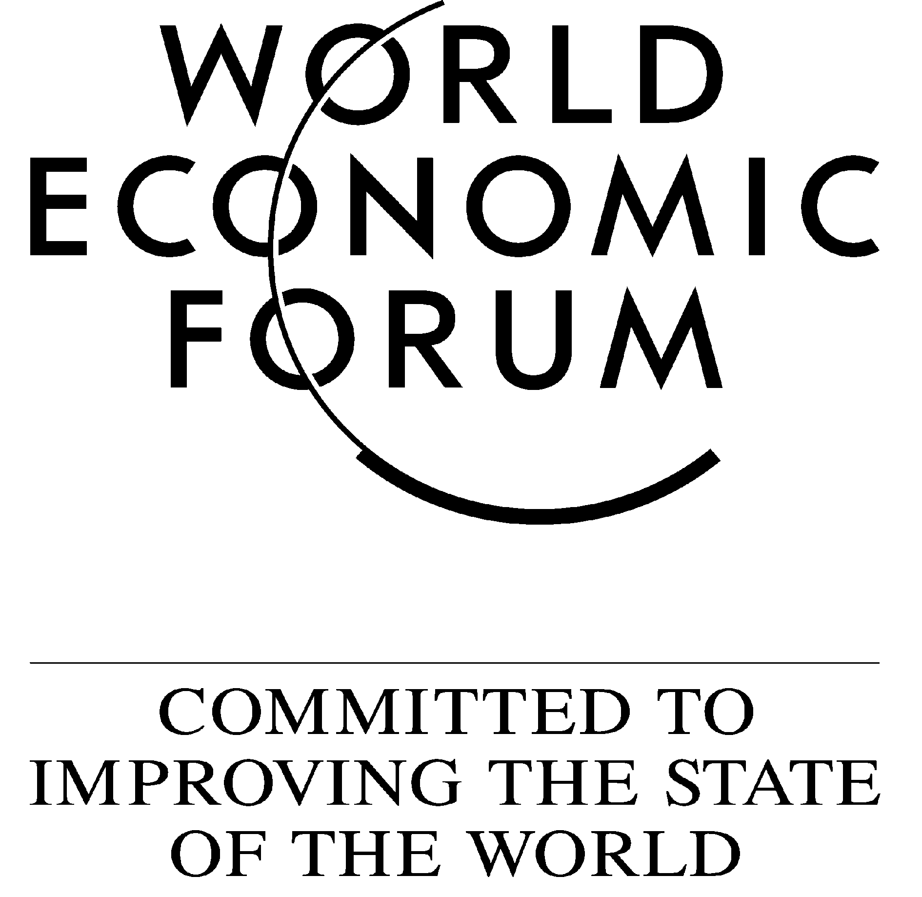

STRICTLY EMBARGOED FOR RELEASE AT 11.00 CENTRAL EUROPEAN TIME (CET)
(10.00 GMT) ON WEDNESDAY 31 OCTOBER 2007

THE UNITED STATES, SWITZERLAND, DENMARK AND SWEDEN TAKE THE LEAD IN THE RANKINGS OF THE WORLD ECONOMIC FORUM’S GLOBAL COMPETITIVENESS INDEX

Germany, Singapore, Japan and the United Kingdom among the top ten

Geneva, Switzerland, 31 October 2007 – The United States tops the overall ranking in The Global Competitiveness Report 2007-2008, released today by the World Economic Forum. Switzerland is in second position followed by Denmark, Sweden, Germany, Finland and Singapore, respectively. Chile is the highest ranked country in Latin America, followed by Mexico and Costa Rica. China and India continue to lead the way among large developing economies. Several countries in the Middle East and North Africa region are in the upper half of the rankings, led by Israel, Kuwait, Qatar, Tunisia, Saudi Arabia and the United Arab Emirates. In sub-Saharan Africa, only South Africa and Mauritius feature in the top half of the rankings, with several countries from the region positioned at the very bottom.

“The United States confirms its position as the most competitive economy in the world. The efficiency of the country’s markets, the sophistication of its business community, the impressive capacity for technological innovation that exists within a first-rate system of universities and research centres, all contribute to making the United States a highly competitive economy. However, some weaknesses, particularly related to macroeconomic imbalances, continue to present a risk to the country’s overall competitiveness potential, and to the global economy as a whole. This danger has most recently been demonstrated by the fallout and contagion caused by the country’s sub-prime mortgage crisis and the ensuing global credit crunch,” said Xavier Sala-i-Martin, Professor of Economics at Columbia University and Co-Editor of the Report.

The rankings are calculated from both publicly available data and the Executive Opinion Survey, a comprehensive annual survey conducted by the World Economic Forum together with its network of Partner Institutes (leading research institutes and business organizations) in the countries covered by the Report. This year, over 11,000 business leaders were polled in a record 131 countries. The survey is designed to capture a broad range of factors affecting an economy’s business climate. The Report also includes comprehensive listings of the main strengths and weaknesses of countries, making it possible to identify key priorities for policy reform.

“Economic policy, especially at the microeconomic level, needs to set priorities that reflect the most important constraints to competitiveness in each country. The GCR enables countries to move beyond abstract theoretical policy debates and identify the specific tasks ahead of them,” explained Michael E. Porter, Harvard Business School Professor, and Co-Director of the Report.

“In an uncertain global financial environment it is more important than ever for countries to put into place the fundamentals underpinning economic growth and development. The World Economic Forum has for many years played a facilitating role in this process by providing detailed assessments of the productive potential of nations worldwide. The Global Competitiveness Report 2007-2008 offers policy-makers and business leaders an important tool in the formulation of improved economic policies and institutional reforms," noted Klaus Schwab, Founder and Executive Chairman of the World Economic Forum.

The Global Competitiveness Index 2007
Country/Economy | 2007 Rank | 2007 Score
United States | 1 | 5.67
Switzerland | 2 | 5.62
Denmark | 3 | 5.55
Sweden | 4 | 5.54
Germany | 5 | 5.51
Finland | 6 | 5.49
Singapore | 7 | 5.45
Japan | 8 | 5.43
United Kingdom | 9 | 5.41
Netherlands | 10 | 5.40

Download the full Global Competitiveness Rankings (PDF or Excel format)

The Global Competitiveness Report’s overall competitiveness ranking is the Global Competitiveness Index (GCI), developed for the World Economic Forum by Columbia University Professor Xavier Sala-i-Martin and originally introduced in 2004. This year’s GCI has been refined based on testing and expert feedback. The GCI is based on 12 pillars of competitiveness, providing a comprehensive picture of the competitiveness landscape in countries around the world at all stages of development. The pillars include: Institutions, Infrastructure, Macroeconomic Stability, Health and Primary Education, Higher Education and Training, Goods Market Efficiency, Labor Market Efficiency, Financial Market Sophistication, Technological Readiness, Market Size, Business Sophistication and Innovation.

A second part of the Report provides a more detailed examination of the microeconomic aspects of competitiveness, presented in the Business Competitiveness Index (BCI) led by Professor Porter. Countries that do well on the GCI also tend to do well on the BCI but there are some important differences. “Many countries have achieved progress by opening up to the world economy, stabilizing macroeconomic policies and removing internal barriers to competition. Our findings reveal the need to build underlying microeconomic competitiveness to translate these gains into sustained prosperity. If improvements in the business environment and company sophistication fail to materialize − and they often require significant shifts in company and country − nations expose themselves to declining competitiveness and are vulnerable to economic and social risks,” said Professor Porter. The BCI finds many European countries, especially Switzerland, Norway and Spain, to have wages much above the level supported by their competitiveness. The BCI rankings and subindexes on company operations and strategy, and business environment quality are found in Chapter 1.2 of the Report entitled “The Microeconomic Foundations of Prosperity: Findings from the Business Competitiveness Index”, which can be accessed online at www.weforum.org/gcr.

The World Economic Forum continues to expand geographic coverage in the Report. Featuring a total of 131 countries, this year’s Report is the most comprehensive of its type. Coverage has been expanded to Puerto Rico, Libya, Oman, Saudi Arabia, Syria and Uzbekistan. In addition, Serbia and Montenegro, previously analysed as a single country, are now included separately.

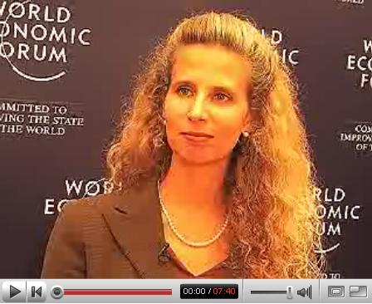
The Report contains a detailed country/economy profile for each of the 131 economies featured in the study, providing a comprehensive summary of the overall position in the rankings as well as the most prominent competitive advantages and competitive disadvantages of each country/economy based on the analysis used in computing the rankings. Also included is an extensive section of data tables with global rankings covering over 110 indicators. (Click on the picture to watch a 6-minute video with the Forum’s senior economist Jennifer Blanke)

This year’s Report also includes a number of discussions of selected countries including Germany, Malaysia, Mexico and the United Arab Emirates, providing an in-depth analysis of the issues affecting national competitiveness.


Notes to Editors:
Here are the highlights of the report.
Download the full Global Competitiveness Rankings (PDF or Excel)
You can watch video interviews with the authors and access specific country profiles at www.weforum.org/gcr
Click here to read the Contents, the Preface as well as Chapter 1.1 and Chapter 1.2 of the Report.
Download print-quality high resolution photographs of the cover and the authors at www.pbase.com/forumweb/gcr
For contact details of any of our Partner Institutes go to http://www.weforum.org/PartnerInstitutes
For updates about the activities of the World Economic Forum subscribe to our RSS feed
Should you require specific information, please contact gcp@weforum.org
The Report, distributed by Palgrave Macmillan, can be ordered online at www.palgrave.com/worldeconomicforum, by telephone at +44 (0)1256 302688, by fax at +44 (0)1256 330688 or by e-mail at orders@palgrave.com

The World Economic Forum is an independent international organization committed to improving the state of the world by engaging leaders in partnerships to shape global, regional and industry agendas.

Incorporated as a foundation in 1971, and based in Geneva, Switzerland, the World Economic Forum is impartial and not-for-profit; it is tied to no political, partisan or national interests. (www.weforum.org)

